Jana Frady | Lab 8

Query 1

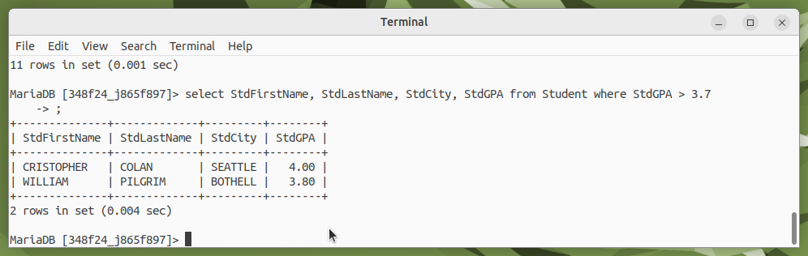Query 2

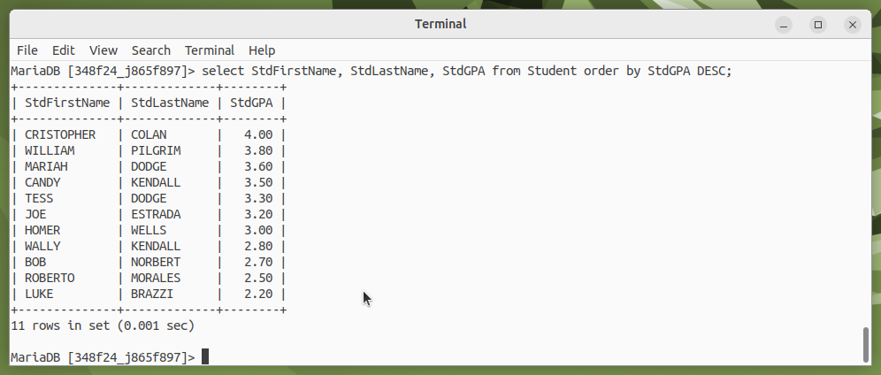Query 3

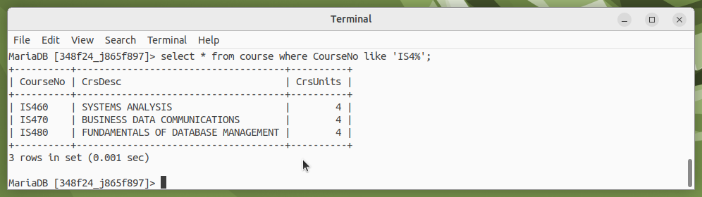

Query 4

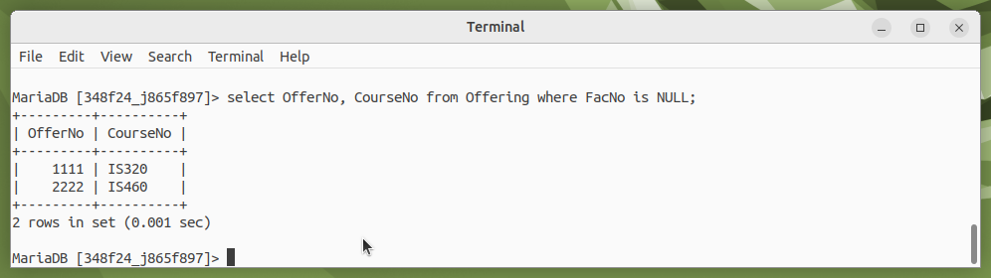

Query 5

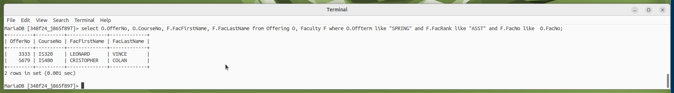

Query 6

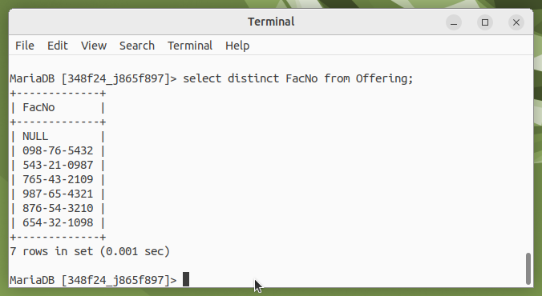

Query 7

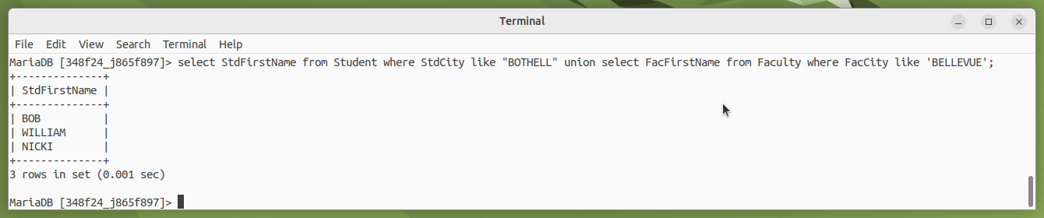

Query 8

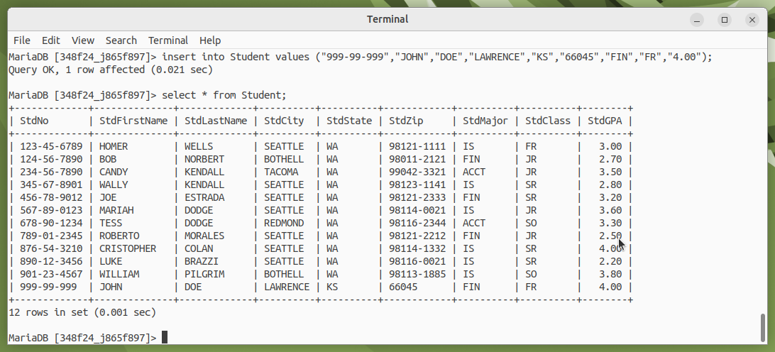

Query 9

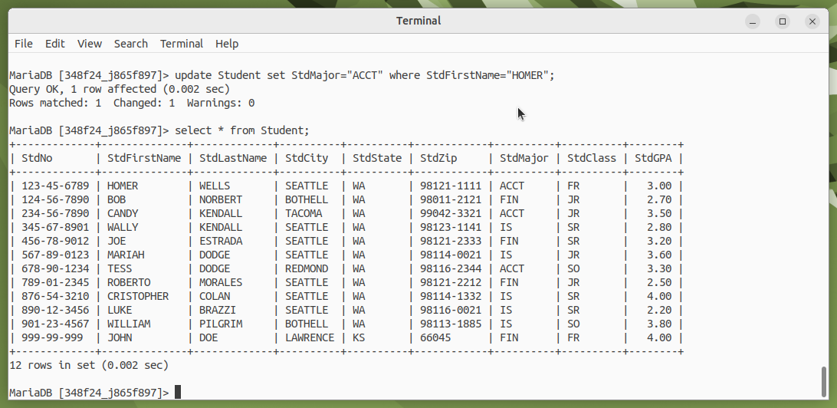

Query 10

